ProCp Application Proposal

Robert Andeescu, 3527638

Artemiy Chervinskyy, 3522644

Ana Cirnu, 3644197

Andrei Fruijna, 3524787

Qi-Mo Lin, 3603296

Ignas Apsega, 3620557

For this project, our team has chosen the **Airport Luggage Simulation**. Our application will simulate passengers coming to the check-in desks and dropping their luggage and the baggage sorting area of the airport which is capable of moving pieces of luggage to the plane.

The number of customers will be randomized, as well as the flights to which the bags will be assigned to. We will also be tracking the following values: the amount of bags put through a specific check-in desk, the number of carts needed to take the bags to the plane and the amount of bags loaded in each plane.

This is our initial design idea:

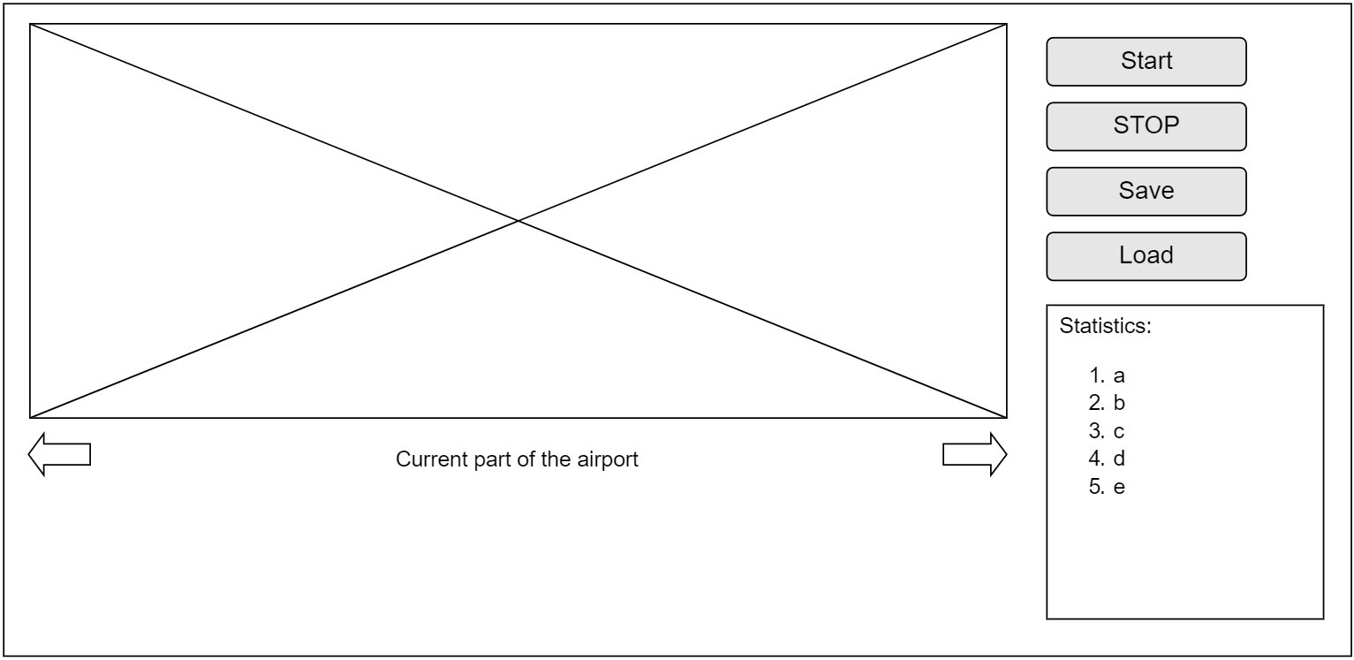

The main screen will display two scenarios: the check-in procedure, the baggage sorting process (these two stages could also be displayed in a single screen, depending on the client’s preference). On the right side of the screen, the following buttons will be located: Start, Stop, Save and Load. The “Save” and “Load” buttons will be used for keeping track of the parameters of the simulation and using them to run the same simulation on demand.